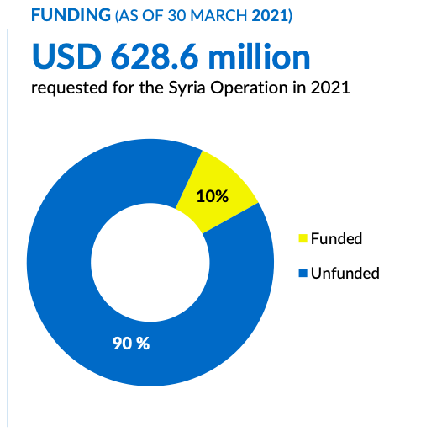
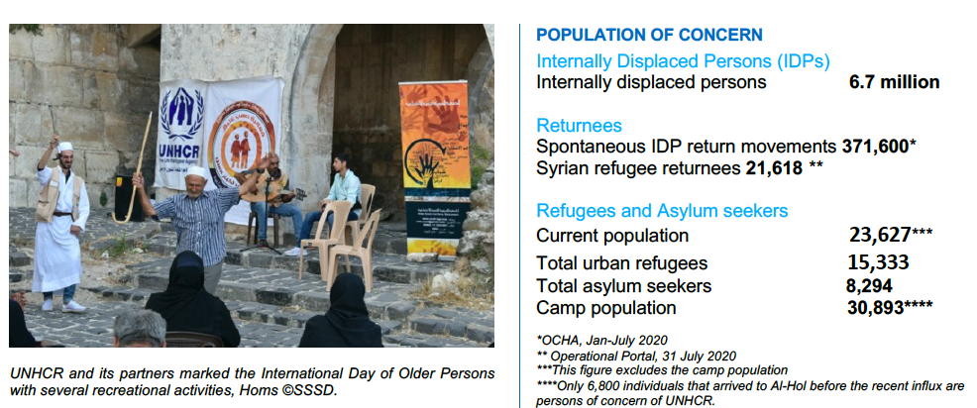
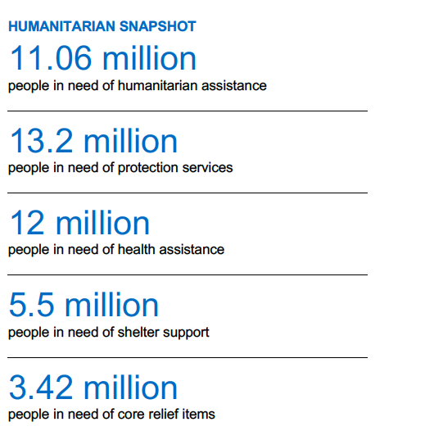
OPERATIONAL UPDATE
Syria situation and COVID-19 Response in the Middle East

The Syrian crisis continues to have profound impact on the lives of ordinary families mainly women and children who face protection risks and need a wide range of humanitarian assistance. The extent to which essential services such as schools, health facilities, electricity and water supply have been affected has had  far reaching implications on the daily lives of ordinary people. |  | Although some of the affected population has returned to their lives, recovery efforts are confronted with the harsh reality of growing economic challenges ranging from the devaluation of the local currency to high prices of essential goods and services. The inability of individual households to meet their  basic needs remains even further compounded by the global COVID-19 Pandemic with its attending negative health and socio-economic impact |  | on already vulnerable communities in Syria. UNHCR with the support of donors is working with the government and partners to assist those in need of humanitarian assistance  under its refugee programme and the wider Syrian humanitarian response as the lead Protection, Non-Food Item and Shelter sector  agency.

UPDATE ON ACHIEVEMENTS
Operational Context

The decade-long crisis in Syria continues to affect millions of lives. Humanitarian needs and protection risks are increasing. The 2020 Syria Humanitarian Needs Overview (HNO) estimates that the number of people in need of humanitarian assistance in Syria is over 13.4 million, including 6.7 million internally displaced people. Of that number, approximately 5.9 million people are in acute need of humanitarian assistance (a 20% increase from 2020). Considering the protracted nature of the crisis, UNHCR and partners provide initial support to returnees and vulnerable people through an area-based approach, which includes immediate shelter repair, rehabilitation of community infrastructure, livelihood support, legal aid, community-based protection, primary health care, and education.
With the consolidation of government control, there has been an increase in the number of internally displaced persons and refugees returning to their places of origin. According to the UN Office for Coordination of Humanitarian Affairs (OCHA), over 448,000 Internally Displaced Persons (IDPs) returned to their areas of origin in 2020. Meanwhile, UNHCR verified 38,233 refugee returns during 2020. Returns of IDPs and Syrian refugees are ongoing.
Through the area-based and village-support programmes, UNHCR is assessing the needs of high return areas to implement integrated interventions including protection, education, shelter, and core relief items (CRIs).
Working in Partnership

Under the overall leadership of the UN Humanitarian Coordinator, UNHCR continues to
lead Protection and coordinates Non-Food Item (NFI) and Shelter sectors in support of the
ongoing humanitarian response in Syria. The agency is working with 74 Protection, 27 NFI
and 26 Shelter agencies in the overall response efforts. Due to the size of the humanitarian
operation in Syria and the area-specific issues in different regions, UNHCR has various
partners and different levels of access. For NFI/Shelter and Protection, there are six subnational coordination mechanisms in Aleppo, Damascus, Dar’a/As-Sweida, Homs,
Qamishli and Tartous. By the end of October, UNHCR, under its refugee and IDP programmes, had partnership agreements with 28 agencies including two government ministries (Ministry of Local Administration and Environment (MoLAE) and Ministry of Higher Education); 20 national and 06 international non-governmental organizations.

Emergency Response

North East Syria
The humanitarian situation in North-East Syria (NES) remains dire with an estimated 1.7
million people in need of humanitarian assistance. Over the last two years, humanitarian
actors have been responding to the needs of some 800,000 people every month with
assistance in IDP sites, spontaneous settlements, and host communities. Currently, there
are four camps as well as informal IDP settlements in Al-Hasakeh, Deir-ez-Zor and Ar-
Raqqa governorates. As of 31 October, the camp population in NES stood at 87,871
individuals (22,740 households) with the largest numbers in Al-Hol Camp, Al-Hasakeh
Governorate. The population also includes about 30,000 individuals who live in collective shelters across all three governorates.

Achievements and Impact

Between January and October, UNHCR Syria provided community-based protection to 864,696 displaced persons, returnees and host community members, including 145,429
individuals provided with legal assistance, 158,748 children with social and recreational
activities in community centres, child-friendly spaces, schools and other outreach activities.
Others included 15,531 students who were supported with remedial classes and catch-up
activities and 77,280 individuals who took part in awareness sessions on Gender Based
Violence (GBV).

Meanwhile, during the same period, 998,019 persons of concern received at least one
core-relief item, 134,947 from UNHCR shelter activities, while 88,067 others were supported through community-based health interventions. UNHCR recorded 3,542 Syrian refugees who spontaneously returned in October. This followed the reopening of the borders by the Government of Syria in July. The borders were earlier closed in March following the outbreak of COVID-19. UNHCR together with its national partners is assessing the needs of returnees at the border entry points and quarantine centre in Damascus. UNHCR is also assisting families in their return areas in Syria.

Protection
By 31 October, the number of UNHCR-funded community and satellite centres reached 128 (92 community and 36 satellite). They were supported by a network of 120 mobile units and 2,659 Syrian Outreach Volunteers (ORVs) associated with 18 national partners.

During the reporting period, UNHCR provided non-formal education programmes through remedial classes and catch-up activities to 801 children, bringing to 13,531 the number of primary and secondary students assisted at community centres since January this year. Out of that number, 142 (1,559 from January-October) children were out of school. Moreover, 1,326 (5,316 from January to October) benefited from Homework Café activity in UNHCR supported community centres.

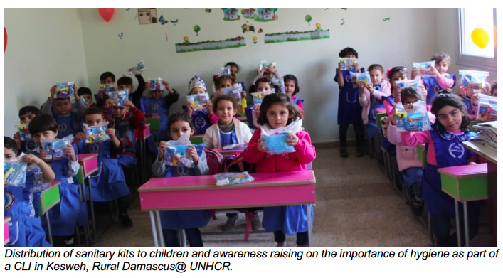

In October, UNHCR partners provided legal assistance to 29,238 displaced persons and returnees in 14 governorates. They included 9,402 individuals who benefited from legal counselling remotely through hotlines, 13,914 individuals from awareness sessions via virtual groups, and 5,922 from direct interventions of lawyers before courts and administrative bodies.

Since the beginning of the year, 145,429 displaced persons, returnees and host community members have benefited from UNHCR’s legal aid programme on issues related mainly to personal documentation, authentication of customary marriages and birth registrations. The programme also provided support in divorce authentication in the context of response to gender-based violence incidents, preserving rights of women and children, property documentation, lease contracts and inheritance. As a result of direct legal interventions by
lawyers, 6,285 individuals obtained national identity cards, 2,821 children were registered and obtained birth certificates, 4,349 women succeeded to document their marriage, and 4,000 obtained family booklets, in addition to 08 HLP- related interventions before courts.

UNHCR and partners in October also identified and assisted 499 GBV survivors; bringing to 2,587 the total number of survivors identified and supported since the beginning of the year. Survivors were referred for specialized services through multi-sector community centre response mechanisms. Furthermore, 660 awareness sessions were conducted (3,864 from January to October) for approximately 13,200 individuals; bring to 77,280 beneficiaries from January to October. To enhance the role of women in the decisionmaking process and in designing activities to address their needs, 03 women committees were established during the reporting period (60 from January-October).

Between January and October, 9,358 awareness-raising sessions on topics related to Child Protection were organized at UNHCR community centres, shelters, child-friendly spaces, schools, and via WhatsApp. Participants included children, caregivers and community members. Through these interventions, UNHCR in collaboration with Syrian partners identified and assisted 4,679 children at risk among displaced persons and in host communities. Main risks identified were child labour, neglect, school dropouts and lack of documentation. Moreover, by the end of October, UNHCR and partners in collaboration with the Ministry of Education, established 91 community-based Child Protection structures across the country including children clubs and child welfare committees. Additionally, 158,748 children benefited from social and recreational activities organized at community centres, child friendly spaces, schools, via phone, social media and other outreach
activities.

To address the specific needs of older persons, 495 individuals in October benefited from home-based training programmes and older persons’ clubs. Through partners, UNHCR also continued its support to children with developmental difficulties by implementing a special home-based rehabilitation programme designed to meet the specific needs of 155 children.

The impact of COVID-19 on the psychological well-being of affected populations remains significant. therefore, during the reporting period, 1,852 individuals received psychosocial support services through community centres and ORVs. Of that number, 423 individuals were referred to specialized mental health services. A total of 24,752 individuals participated in 3,094 social and recreational events including awareness raising sessions. These activities were conducted remotely through virtual groups to increase the awareness on the psychological effects of COVID-19. Due to the Ministry of Health and WHO instructions on COVID, different types of general and medical in-kind assistance were also provided to 9,788 vulnerable individuals to help them meet their various basic needs.

Shelters and NFIS
In October, UNHCR provided 260,409 individuals with at least one core relief and supplementary items. This brough to 998,009, the total number of individuals assisted between January and October this year.

In addition, 134,947 individuals were supported with shelter and infrastructure assistance,
which included the installation of 654 shelter kits in Aleppo and Al-Hasakeh that benefited
4,748 individuals. Also, 5,124 tents were distributed in Al-Hol, Areesha, Mahmoudli, Newroz, Roj, Abu Kashab camps and Tel Samen informal settlement in the North East Syria. Infrastructure repair to meet existing and new displacement needs were also provided. 16 damaged buildings were repaired in Aleppo benefiting 775 individuals. Additionally, 1,927 damaged houses were being repaired in Dar’a, Aleppo, Lattakia, and Rural Damascus to benefit some 3,218 individuals.

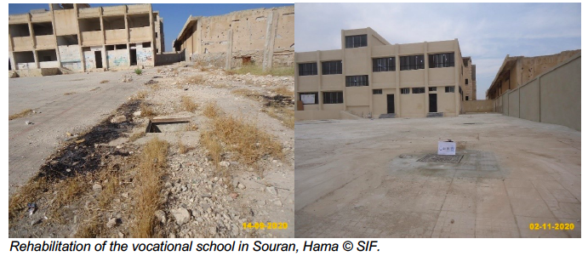

Between January and October, 508 shelter packages including doors, windows, electrical and water & sanitation materials were installed in Aleppo, Deir-ez-Zor and Quneitra.

As a further response to the COVID-19 emergency, 111 emergency shelters in three collective shelters were being rehabilitated to support 555 individuals in Lattakia and Tartous. The construction of 479 units in five collective shelters in Hama started in October. Furthermore, 15 rub halls with the capacity to accommodate 650 persons of concern were equipped with fans, windows, beds, and lightings. This was in addition to the rehabilitation of the existing infrastructure to improve the living conditions of returnees in Al Dweir Centre with the capacity to support 600 individuals.

Camp fumigation and sterilization started in eleven formal and informal camps, and collective shelters in NES hosting 119,291 individuals. Two isolation centres were completed in Al-Hol Camp, Al-Hasakeh Governorate to support 70 individuals.

UNHCR through its partners provided 215 solid waste bins, rehabilitated 2,045 linear meters of sewage system, upgraded 400 linear meter of water network, and removed 62,500 cubic meters of debris to benefit 86,225 individuals.

A plan to support the capacity building of 800 partner staff started in October. In addition, 46 engineers were trained in Aleppo during the same period.

Health
Between January and end of October, UNHCR assisted 187,533 displaced persons with Primary Health Care (PHC) services through 11 clinics. They included 5,235 IDPs provided with Mental Health and Psychosocial Support (MHPSS) services through SARC clinics in Damascus and Rural Damascus.

During the reporting period, 88,067 individuals were reached by community-based health activities through health points in community centres. Also, 14,893 individuals received basic medical consultation at 26 health points functioning in Rural Damascus, Aleppo, rural Aleppo, rural Hama, rural Homs, Tartous, rural Tartous, Quneitra, rural Dar’a, and Al-Hasakeh. 73,174 individuals also participated in and benefited from health promotion and disease prevention activities conducted by the community-health workers in and out of
community centres.

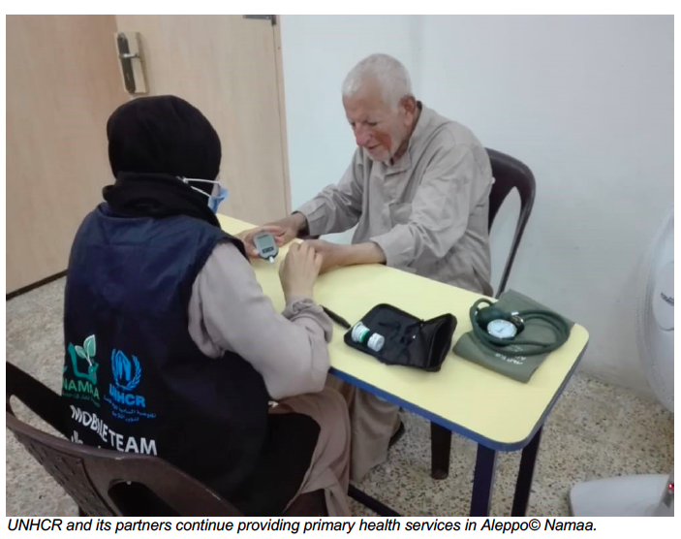

Livelihoods and self reliance
By end of October, UNHCR assisted 1,257 individuals through entrepreneurship training courses in 12 governorates. Of that number 279 received support to operate start-up small business projects in nine governorates. Additionally, 3,109 individuals received livelihood support through the provision of agricultural inputs in Hama, Homs, Idleb, Dar’a, and Tartous. The support included provision of seeds, livestock, drip irrigation and other inputs prioritized by returnee farmers in the selected villages. UNHCR also supported 117 individuals through cash-for-work activities in Al-Hol Camp, benefiting women headed households and persons with disabilities. UNHCR also continued the rehabilitation of several economic infrastructure projects in Homs, Hama, Tartous, Dar’a, Rural Damascus, Aleppo, and Al-Hasakeh including public bakeries, vocational training schools, and public markets.

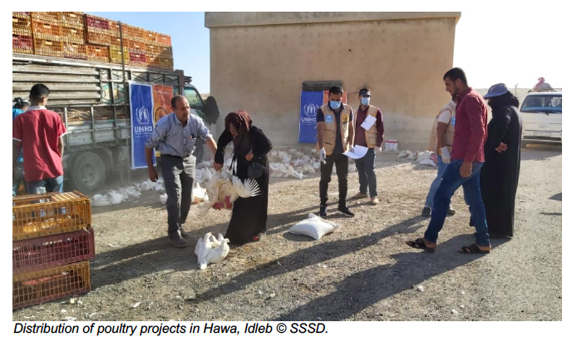

Protection and assistance to refugees
In October, UNHCR continued the cash distribution to eligible refugees through cash over the counter modality for the months of September and October in conjunction with the education assistance for eligible refugee children between 6 and 17 years old. The distribution of the education grant will continue for refugee children between 5 and 18 years
until the end of the year.

12,257 individuals from 4,304 refugee families benefited from multi-purpose cash grants (MPCGs). This brought to 13,690 individuals, the total number of those assisted under the
MPCG scheme since January this year. In addition, 4,164, refugees from 1,949 families
benefited from the education grant. UNHCR also provided cash related hotline support to
1,124 families during the reporting period.

Interviews were undertaken for 03 individuals/01 family. Until the end of October, the overall
Refugee Status Determination (RSD) interviews conducted by UNHCR for asylum seekers
at different stages were 17 individuals from 07 families. Decisions were submitted for 11
individuals/03 families, and the total number of RSD submissions from January to October
were 38 individuals from 20 families.

Additionally, UNHCR conducted 6 resettlement interviews for 5 families / 59 individuals/ 40
families from January to October. None of those interviewed in October was recognized. That said, between January and September, 17 individuals/10 families were recognized as
refugees.

It is estimated that there are currently 1,900 refugees in need of resettlement in Syria. Submissions to potential resettlement countries remained suspended due to ongoing COVID restrictions. However, in October, UNHCR Resettlement Hotline counselled 1,090 persons on resettlement related issues.

Two UNHCR-supported community centres functioning in Al-Hasakeh Governorate provided wide range of protection services to refugees including child protection, SGBV livelihoods.

As of end of October, 126 Outreach Volunteers (ORVs) supported refugee communities in Damascus, Rural Damascus, Aleppo and Al-Hasakeh governorates. The ORVs were comprised of refugees from Iraq, Somalia, Sudan, South Sudan, Yemen, Afghanistan, Chad, Guinea and Eritrea in the four governorates.

UNHCR through a dedicated education hotline, provided individual counselling and information to 220 refugees on education cash grant distribution as well as university scholarship program. From January to October, 668 refugees were assisted with individual
counselling and information on education cash grant distribution.

22 GBV survivors were identified during the reporting period and supported with needed services including referrals – bringing to 80, the total number of survivors identified and supported since January this year. Additionally, 14 referrals were made, and survivors linked to ORVs to ensure the support network within their communities. That brought to 68, the total referrals made from January to October. In addition, 59 GBV awareness sessions were conducted on psychological violence, deprivation of resources, opportunities and services, early marriage, sexual harassment, and physical violence – bringing to 133, the total number of sessions since January this year conducted in Al-Hassakeh governorate (Tal Hamis and Al- Hol Camp) with the participation of 939 individuals mostly adolescent females and adult women (2,304 from January-October). The number of refugee committee members reached 1,158 between January and October.

Also, 17,193 refugees and asylum seekers received free-of-charge comprehensive primary health care services through 10 UNHCR-supported primary health care clinics. 740 of the
beneficiaries received mental health services through SARC clinics in Damascus and Rural
Damascus. Secondary and tertiary health care were also provided to 2,282 of the beneficiary population through designated public, charitable and private contracted hospitals in Syria.

Support to spontaneous returns
The number of the verified refugee returns by UNHCR during October stood at 3,542.

During October, UNHCR provided non-formal education programmes through remedial classes and catch-up activities to 294 returnee students totalling 11,919 since January this year at the primary and secondary school levels in community centres. 122 children were documented to be out-of-school. That brought to 1,121, the total number of out of school children recorded from January to October. Additionally, 1,459 children (6,050 from January-October) benefited from Homework Café activities in UNHCR supported community centres.

As of end of October, 4,749 awareness raising sessions on Child Protection topics were organized at UNHCR community centres, shelters, child-friendly spaces, schools and virtually. The participants included children, caregivers and community members. Through these interventions, UNHCR in collaboration with Syrian partners identified and assisted 4,213 children at risk among the returnees and host communities. The main risks identified
were neglect, school dropouts, maltreatment and those subjected to violence. Moreover, by 31 October, UNHCR along with partners including the Ministry of Education established and supported 89 community-based Child Protection structures across the country. They included children clubs and child welfare committees. Additionally, during the reporting period, 89,844 returnee children benefited from social and recreational activities conducted
in community centres, child friendly spaces, schools, via WhatsApp, and other outreach activities.

During the same period, UNHCR and partners identified and referred for specialized services 388 survivors of SGBV through the community centres - bringing to 2,339 the total number of survivors referred since January. Furthermore, approximately 11,720 women participated in 586 awareness sessions conducted to enhance their role in the decision-making process and in designing activities to address their needs. Between January and October, approximately 61,480 women participated in 3,074 awareness sessions.

During the same reporting period, UNHCR supported 674,135 returnees from approximately 134,827 returnee families with core relief items and seasonal items including rechargeable fans in summer and extra blankets and plastic sheets, sleeping bags, jackets and other clothing during the winter.

UNHCR Missions in the field
UNHCR conducted 61 missions in the October 2020, bringing to 471, the overall missions undertaken to 74 sub-districts in Al-Hasakeh, Lattakia, Aleppo, Tartous, Homs, Hama, Damascus, Rural Damascus, Idleb, and Ar-Raqqa. UNHCR staff from Protection, Shelter, NFI, Health and Livelihood units participated in the missions, which were used to follow up on the work of partners and ORVs on the ground. The missions also visited return areas to
meet with returnees and produce sub-district profiles, monitor NFI distribution and assess the overall humanitarian needs in the different sectors.

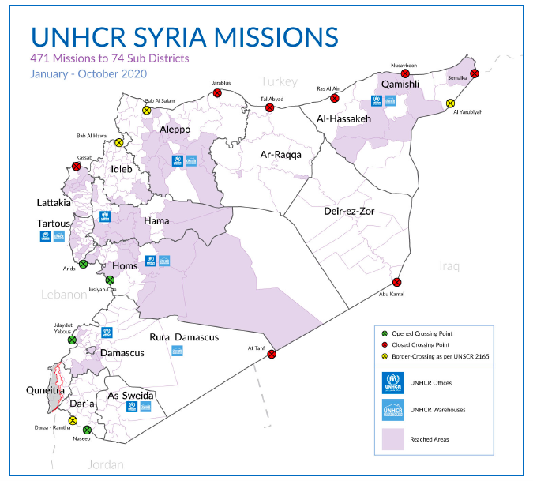

COVID-19 Response in the Middle East
UNHCR Syria Response

In support of UNHCR’s COVID-19 response in Syria, 853,659 individuals benefited from variety of services including awareness and information campaigns, distribution and community training by 31 October. Of that number, 121,355 individuals were reached through 860 different virtual groups; 321,445 through outreach volunteers and 102,216 through UNHCR mass communication campaigns. Also, 101,740 calls were received by hotline on child protection, gender-based violence, legal, mental health and Psychosocial Support (PSS), health and other related issues, and 61,805 medical consultations were provided. 137,997 individuals benefited from community-led initiatives (CLIs) conducted through 51 professional trainings on COVID-19. 208,262 examination gloves, 214,879 surgical masks and 8,751 alcohol hand rub gel sanitizers were also distributed in community centres, distribution points and health facilities.

UNHCR Iraq Response

As part of its efforts to limit the spread of the virus and preserve the well-being of refugees, IDPs, and returnees across Iraq, UNHCR continues to support families’ access to basic hygiene items through the distribution of cash assistance and sanitary kits. To date, a total of 100,335 displaced families (over 565,500 individuals) have cashed out their assistance (35,026 refugee families and 65,309 IDP families). Further to the cash assistance, UNHCR has also distributed over 77,780 sanitary kits including hygiene and sanitary items for women and girls of reproductive age living in IDP and refugee camps.

UNHCR continues to implement a series of activities aiming to reduce the spread of the virus in Iraq, particularly among the most vulnerable displaced populations. These activities include health awareness campaigns on COVID-19 in all refugee camps in Iraq as well as in most IDP camps and accessible urban areas with a high concentration of displaced individuals. Awareness remains key to flatten the COVID-19 infection curve in Iraq. Since the beginning of the outbreak, UNHCR has been distributing brochures and posters on COVID-19 preventive measures to persons of concern, camp-based Primary Health Care Centres (PHCC), camp management, and community outreach volunteers. In addition, UNHCR is collaborating with the Iraq Information Centre (IIC) and the Camp Coordination and Camp Management (CCCM) cluster in issuing sanitation and hygiene-related awareness-raising SMS's addressed to vulnerable displaced populations.

As part of the response to the COVID-19 outbreak in Iraq, UNHCR has also provided medical personal protective equipment (PPE), masks with filters, disposable shoes, surgical masks, gloves, and disposable medical gowns to medical staff in camps and at borders. In Duhok, through the mask sewing project, refugee tailors produced some 1,230 reusable masks bringing the cumulative total to 9,400 reusable masks, which are being distributed in Domiz I, II, Bardarash, Akre, Gawilan camps, and Derabon return centre. UNHCR, through CwC partner, has launched the home mask-making campaign in Duhok governorate since mid-November with the aim to provide simple instructions on how to make reusable masks at home to support and empower POCs who may not afford to buy a mask. It has reached some 5,280 POCs (3,400 refugees, 1,400 IDPs, 480 host community members) to date. Furthermore, UNHCR has provided training to camp management and PHCC staff on case definition, detection and management, and has identified potential quarantine and isolation sites within IDP and refugee camps across the country in coordination with DoH and WHO.

UNHCR Jordan Response

Through 2020, UNHCR Jordan continued to monitor and respond to the COVID-19 situation among refugees, in close coordination with the Ministry of Health and the Syrian Refugee Affairs Department. As the country has confirmed that refugees will be included in the COVID-19 vaccination plan, UNHCR is working with MoH to make the necessary preparations to support refugees in the vaccine registration. Distribution of winter cash assistance continued in December and reached some 53,000 refugee families in the last two months of the year to support with increased needs during the cold weather.

In December, UNHCR provided Urgent Cash Assistance to 153 vulnerable refugee families. For PoCs who test positive for COVID-19, UNHCR community-based protection teams have been following up on individual cases through phone counselling, to better understand the impact of COVID-19 on urban refugee populations and assess the needs and existing gaps in assistance.

Since the beginning of the pandemic in March 2020, UNHCR and other Basic Needs partners also distributed COVID-19 emergency cash assistance to a total of 56,222 newly identified vulnerable families. Each of those families received at least one round of assistance, with the total amount of assistance disbursed by UNHCR reaching USD $26.5 million.

During December, UNHCR continued to respond to COVID-19 in camps, working closely with the Ministry of Health (MoH) and the Syrian Refugee Affairs Directorate, to carry out surveillance and contact tracing exercises. Confirmed cases are being quarantined either in their own shelters or at isolation sites and transferred to hospital as needed as per the established protocol. In Azraq, the construction of the Coronavirus Treatment Centre was completed, and the centre is operational and receiving patients.

As Jordan is preparing to receive the COVID-19 vaccine and initiate vaccinations, UNHCR together with MoH initiated preparations in Azraq and Za’atari camps, including identifying vaccination locations and preparing lists of the first groups of refugees to be prioritized for vaccination. UNHCR has also been supporting persons of concern in urban and camp settings to access the government COVID-19 vaccine platform and registry. Vaccinations are expected to start by mid-January.

UNHCR Lebanon Response

While the COVID-19 related restrictions affected the implementation of some programmes in Lebanon, UNHCR adapted the delivery modalities of many protection services to remain responsive to the needs of refugees and developed remote case processing modalities for registration, renewal and verification activities. In doing so, UNHCR expanded its availability through the national call centre and field hotlines to respond to an increasing number of protection, assistance and other queries. Individual case management was conducted by phone wherever possible. Core assistance programmes, including cash-based interventions and health, have been maintained throughout. As of July 2020, all four UNHCR reception centres gradually re-opened with precautionary measures in place to keep refugees and staff safe. Nevertheless, operations continuously adjusted in line with government decisions throughout 2020. In-person appointments at Reception Centres were prioritized for the most urgent protection, registration, documentation, status determination and resettlement cases. Resettlement departures were able to resume in late July.

In 2020, UNHCR also supported the establishment of 13 isolation facilities throughout the country. Of these, 10 sites are currently ready to receive patients with an operational capacity to host 569 COVID-19 infected persons in need of isolation outside their home. Two of the original centres (one in the Bekaa and one in the North) were closed down due to the repurposing of the buildings by their landlords, after having been operational for a several months throughout the year. The remaining isolation centre is in the process of being completed. Efforts to further expand the capacity at Municipal isolation centres are still ongoing in 2021 and additional locations, where needed, are being explored.

In light of the overstretched public health system, UNHCR supported Lebanon throughout 2020 with expanding the hospitalization capacity for COVID-19 through the design, construction and equipping of temporary COVID-19 units annexed to selected hospitals, or through the rehabilitation of existing unused structures within hospitals which were transformed into COVID-19 units. Besides civil works needed to expand the hospitals with additional wards, UNHCR’s support also included infrastructural works which were necessary to expand the hospitals’ central support systems, such as the central O2 and compressed air supply.

Overall, UNHCR’s COVID-19 response encompassed a plan to add 800 hospital beds and 100 ICU beds in hospitals across Lebanon, in a phased approach with activation upon reaching a certain threshold in the number of positive cases.

Your generous contribution supported UNHCR Syria’s efforts to provide critical lifesaving protection and response to refugees/IDPs/returnees and the host community alike during an exceptionally trying year. On behalf of the men, women and children who have benefited from the Kuwait-America Foundation’s support – THANK YOU!

